🐞 4. DEFECT REPORT

4.1 Defect Summary
Bug ID | Module | Severity | Priority | Status
BUG-001 | Login | High | High | Open
BUG-002 | Customer | High | High | Open
BUG-003 | Deposit | High | High | Open
BUG-004 | Withdrawal | High | High | Open
BUG-005 | Mini Statement | High | High | Open

4.2 Detailed Defects

🐞 BUG-001 – Invalid Login Accepted
- Expected: Error message should be displayed for invalid credentials
- Actual: Login is allowed without proper validation
- Impact: Security vulnerability in authentication system

🐞 BUG-002 – Duplicate Customer Allowed
- Expected: System should prevent duplicate customer creation
- Actual: Same customer is created multiple times
- Impact: Data inconsistency and redundancy

🐞 BUG-003 – Negative Deposit Accepted
- Expected: System should reject negative deposit values
- Actual: Negative amount is processed successfully
- Impact: Financial data inconsistency

🐞 BUG-004 – Overdraft Not Restricted
- Expected: Withdrawal should not exceed available balance
- Actual: System allows withdrawal beyond balance
- Impact: Financial loss risk and incorrect balance

🐞 BUG-005 – Mini Statement Failure
- Expected: Transaction history should be displayed correctly
- Actual: Page shows error or empty results
- Impact: Reporting and user trust failure

📊 5. RISK ANALYSIS
Risk Area | Severity | Impact
Transaction Validation | High | Financial inconsistency
Customer Duplication | High | Data integrity issue
Authentication | High | Security risk
Reporting | Medium | User trust issue

🧠 6. FINAL CONCLUSION
The Guru99 Bank Automation Framework successfully validates major banking workflows using a robust automation architecture built with:
- Selenium WebDriver
- TestNG
- Maven
- Jenkins
- Page Object Model (POM)

✔ Strengths
- High automation coverage of core banking modules
- Stable execution of major transaction flows
- CI/CD integration using Jenkins
- Reusable and maintainable framework design

❌ Weaknesses
- Weak validation in login module
- Data integrity issues in customer module
- Transaction validation gaps (deposit/withdrawal)
- Reporting inconsistencies in mini statement

Jira Bug Screenshot:

Login Module:

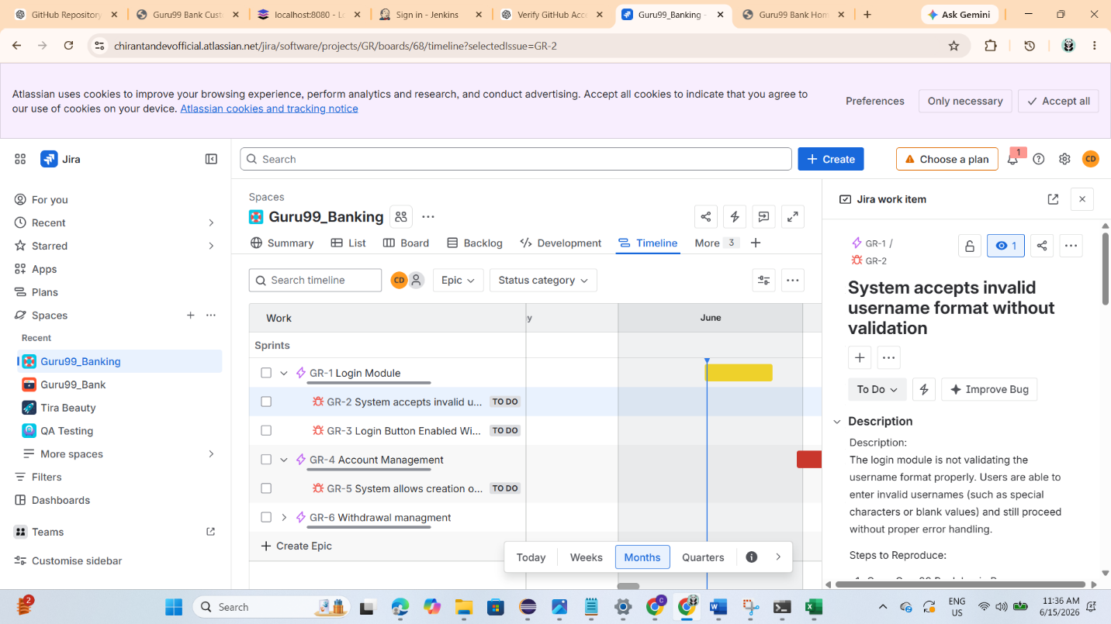
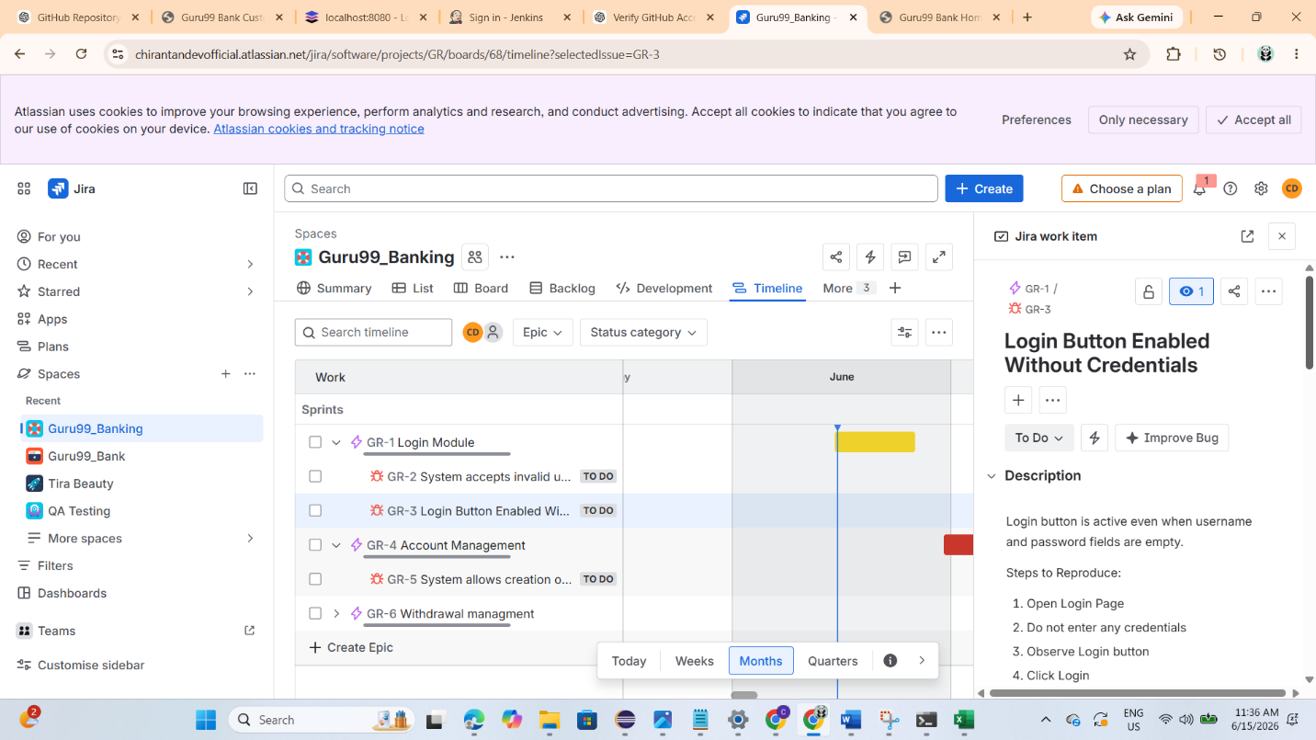

Account Managemnet:

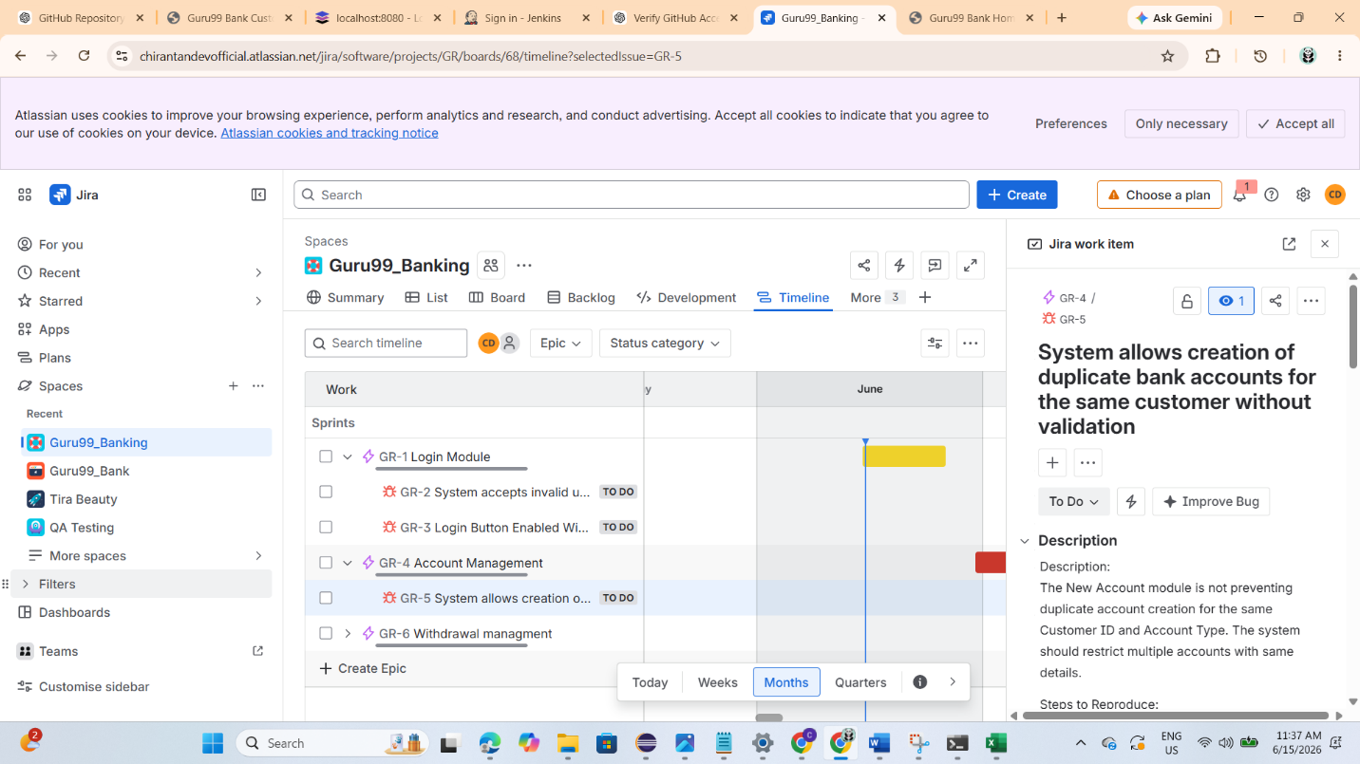

Withdrawal Managemnet:
